Transistor BC548
CP011
Image:
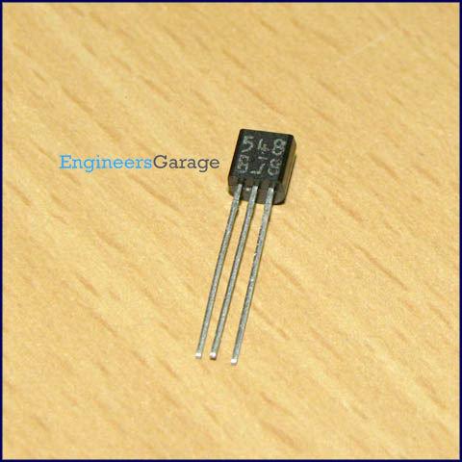
DataSheet:
BC548.pdf
BC548 is general purpose silicon, NPN, bipolar junction transistor. It is used for amplification and switching purposes. The current gain may vary between 110 and 800. The maximum DC current gain is 800.

Its equivalent transistors are 2N3904 and 2SC1815. These equivalent transistors however have different lead assignments. The variants of BC548 are 548A, 548B and 548C which vary in range of current gain and other characteristics.

The transistor terminals require a fixed DC voltage to operate in the desired region of its characteristic curves. This is known as the biasing. For amplification applications, the transistor is biased such that it is partly on for all input conditions. The input signal at base is amplified and taken at the emitter. BC548 is used in common emitter configuration for amplifiers. The voltage divider is the commonly used biasing mode. For switching applications, transistor is biased so that it remains fully on if there is a signal at its base. In the absence of base signal, it gets completely off.

Pin Diagram:
